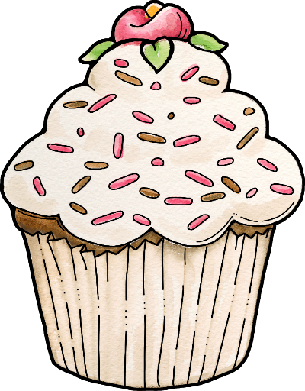
Parts of Speech Sort

By: Rae Burch
Clipart by Gina Jane

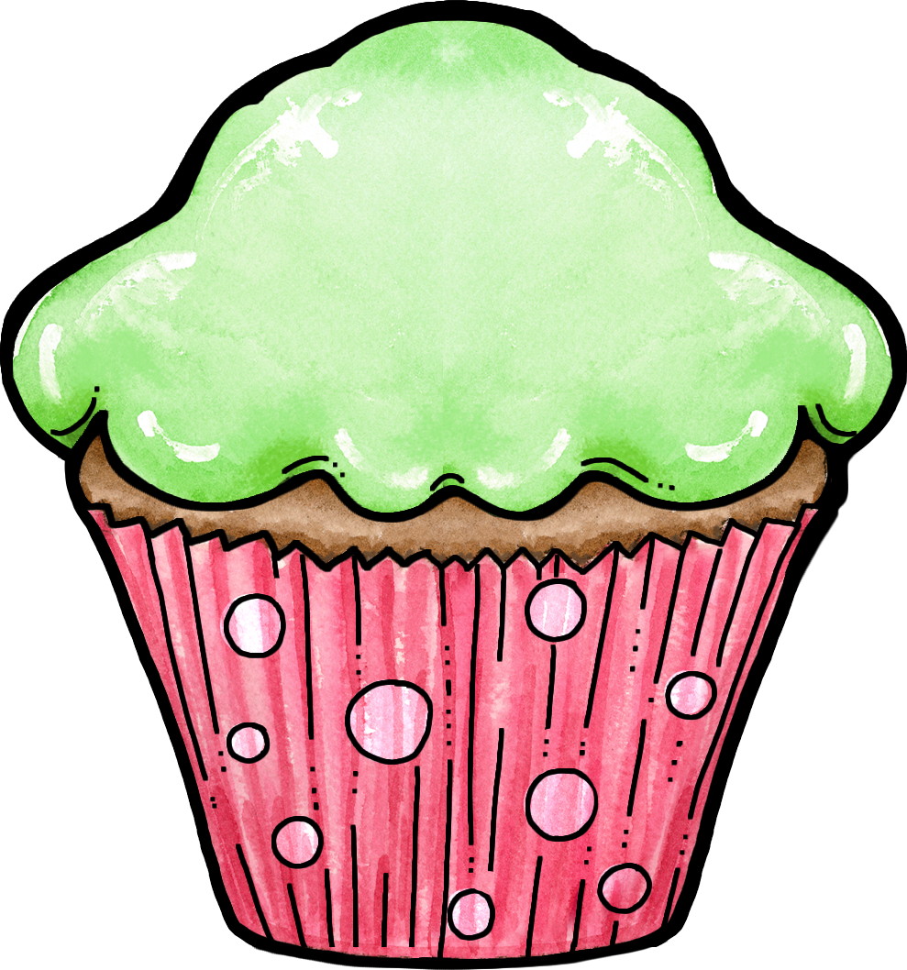

NOUNS

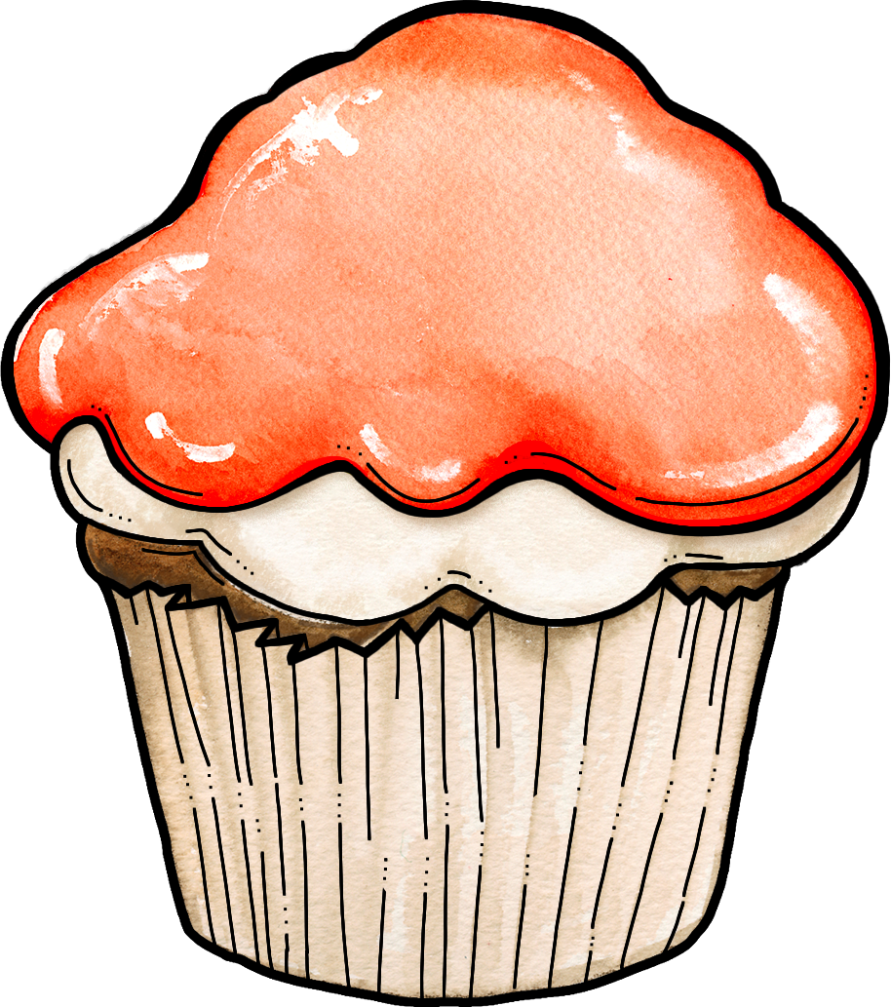
VERBS

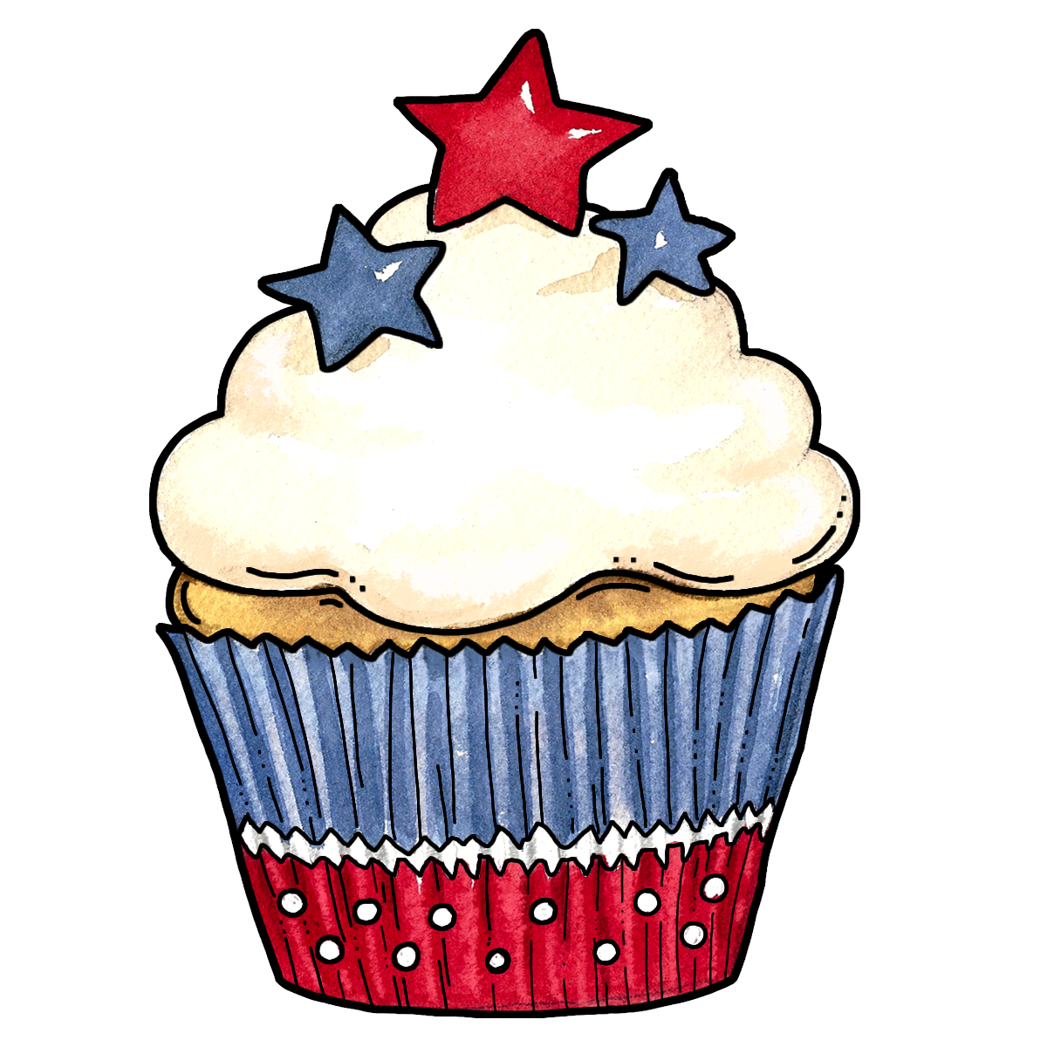

ADVERBS

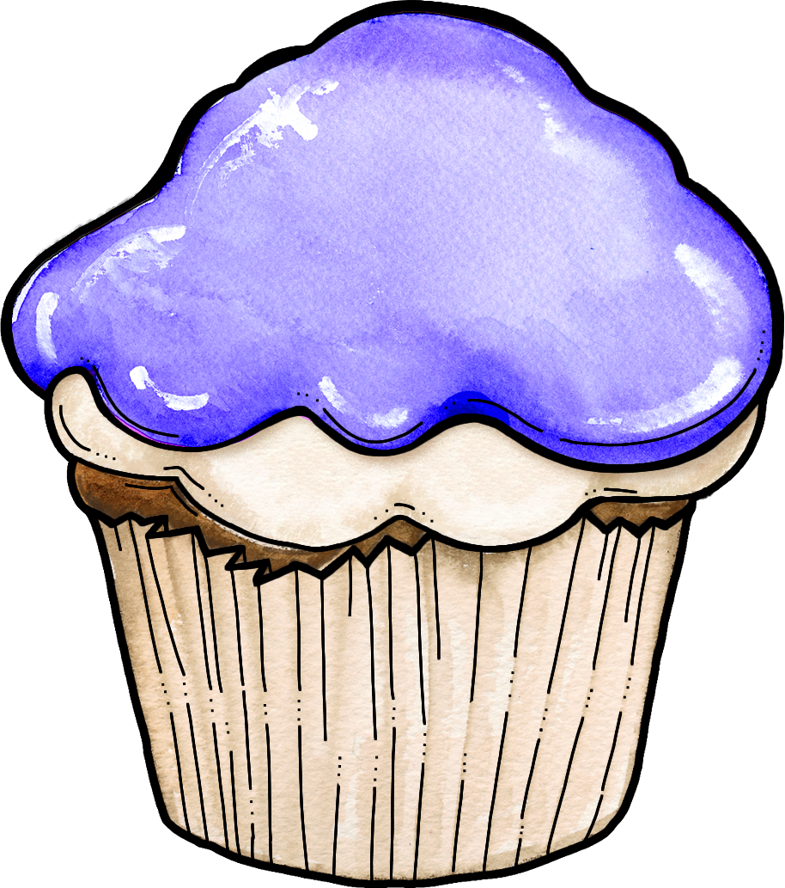

PRONOUNS

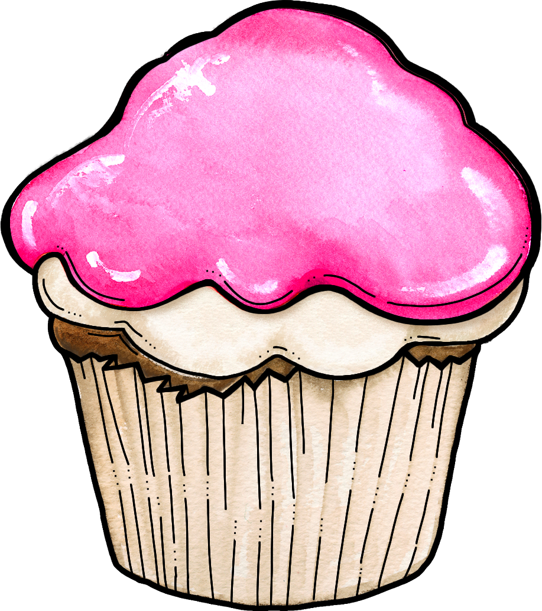

PREPOSITIONS



CONJUNCTIONS

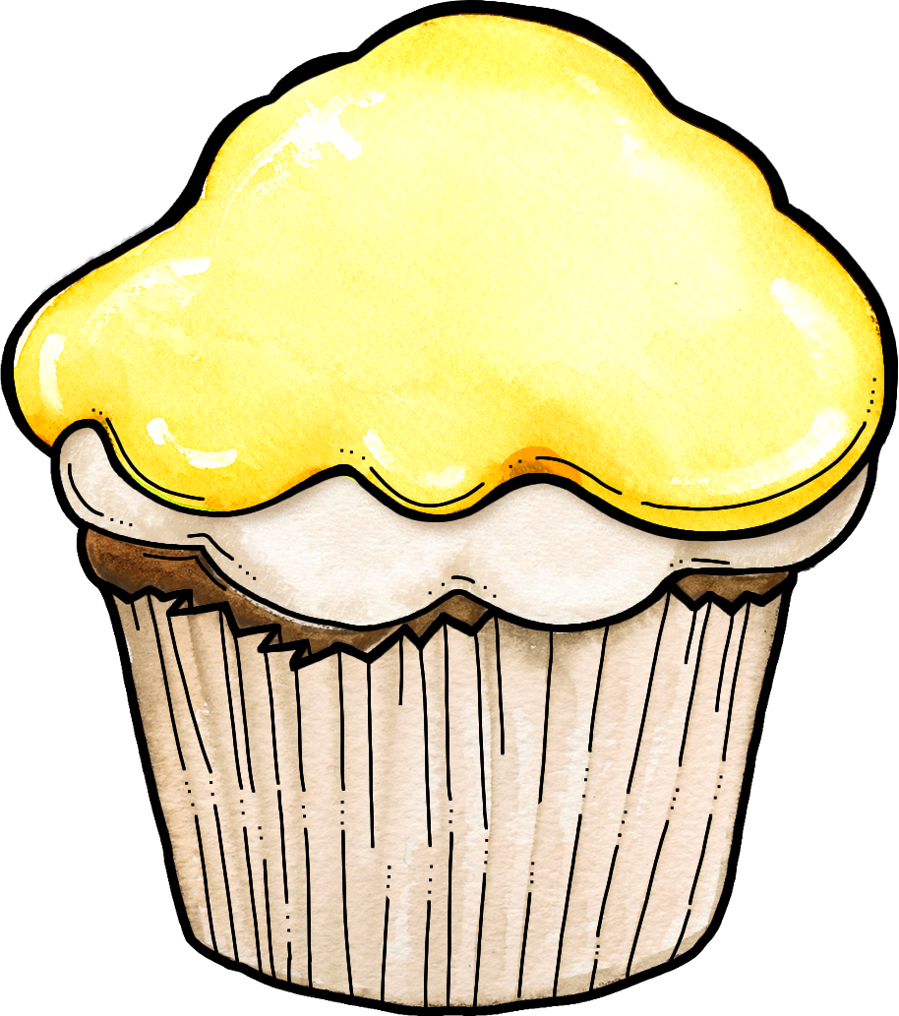

INTERJECTIONS

NOUNS






VERBS






ADVERBS






PRONOUNS






PREPOSITIONS






CONJUNCTIONS






INTERJECTIONS






BLANKS






Black and White


